6th February 2023
Dear Families,
As we continue to work hard to keep our home COVID-free, we are now responding to the recommended changes for visitor restrictions.
We understand that your loved one is palliative and at end of life and visits are essential. However, we must maintain the well-being of our staff team because without them we can not care for your loved one.
Enclosed in this letter are our new visitor policies that have been implemented.
Your cooperation is needed to help keep your loved one and our staff safe. If as a visitor, you do not comply you will be asked to leave the building until you can comply. If repeated non-compliance we will ban a visitor. We do not wish to do this however, it is for the health and safety of our staff team, patients, and other visitors.
We thank you for your cooperation, compassion, and support in keeping our home COVID-free. If you have any questions, please do not hesitate to contact me.

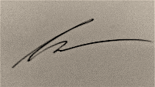
Sincerely,
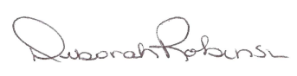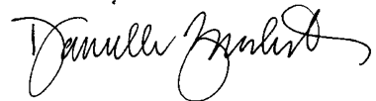
Debbie Robinson, Reg. N. CHPCN(c) Danielle Zucchet, H. BSc Susan Repa
Director of Nursing Services Chief Executive Officer Director of Program and Services

Visitor Policies

MASK & SOCIAL DISTANCING
- Mask Policy: Our mask policy is still in effect. We ask that you keep your mask on while visiting your loved ones, at all times while in the building.

VISITING/SCREENING HOURS:
Visitors are permitted to come and go as they will be given a code to enter the building. Only 4 visitors are permitted in the room at one time so please preplan your visits.

VISITORS
- Each family will be given a code to enter the building. Visitors who show up unannounced without a code will not be permitted to enter the building.

- Up to four visitors can be in the room at one time and we ask that you schedule visits with your family and friends to plan for this.

- All visitors will need to complete self screening at the door before entering and complete a rapid antigen test every 2nd day if visiting.

- When end of life is imminent (within hours) four visitors will be permitted to be at the bedside. (When staff needs to enter the room during this time, two visitors will need to leave the room).

- Up to Two (2) people will be permitted to stay overnight.

- If you are feeling unwell or experiencing any symptoms, we ask that you do not come to visit to reduce the risk of exposure to your loved one and our staff. Please continue to self-screen upon arrival.

- Window visits: Will be permitted provided the visitors outside maintain social distance from other outside visitors and masks are always properly worn.

- NO OPENING DOORS: No visitor will be permitted to open any exterior doors within the building to allow for others to either enter the building or to stand by and talk.

